**Modelling the Effectiveness of Malaria Case Management Cascade: A Kenyan Effective Treatment Estimation Model**







Candidate no. 1083832

Submitted in partial completion of the

*Master of Science in Modelling for Global Health*

August 2024

**Acknowledgments**

This dissertation could not have been possible without the tireless support of the project placement team and my placement supervisor, who graciously offered me all the necessary support to conceptualize and execute this study analysis. Special gratitude to my placement team who provided timely and valuable feedback. I want to sincerely thank the entire Modelling for Global Health team and my academic supervisor, for your faith in me, valuable feedback and the support to realise a lifetime dream. Finally, to my spouse, my family, fellow course mates and my college friends thank you for your continued emotional support and push

**Manuscript Submission**

This manuscript will be submitted to the PLOS Global Public Health, and was guided by the standard PLOS guidelines of submission. Other journals such as the malaria journal among other are also being considered

**Abstract**

Improved malaria control efforts and coverage across sub–Saharan Africa can be attributed to more than 1.785 billion malaria cases prevented and 11 million deaths averted in the period 2000 – 2022. Prompt diagnosis and effective treatment with recommended artemisinin-based combination therapy (ACT) is one of the key control strategies. Data on how much effect case management of malaria has on Incidence and prevalence is scarce. Kenya reported 3.6 million confirmed cases and 4,000 deaths reported in 2022. Despite availability of efficacious treatment, there are suspected malaria cases that don’t promptly seek or access appropriate healthcare. Successful effective treatment of malaria cases relies on a sequence of events within a health care system. Effective case management coverage estimation concepts, take into account how certain factors affect this sequence of events.

Our work proposed to estimate proportion of clinical malaria cases effectively treated based on an analysis of recent Demographic Health Surveys. A decision tree model was adopted and updated, including data from literature reviews for non-demographic survey parameters. A compartmental SIS model was used to explore the impact of effective coverage improvements on malaria prevalence and incidence. An interactive platform for stakeholders to explore the impact was developed.

Our analysis found effective coverage estimate varied 39% in 2003 to 54% in 2022. In the lake endemic region on average 59.1% malaria fevers were effectively treated in 2022. On average 68.5% fevers were managed in either the formal or informal healthcare systems. Formal care systems treated 82.9% of fevers when care was sought and 82.9% of service providers complied with the first line treatment policy. Our SIS model supported case management strengthening leads to malaria incidence decline. We hope our work shows the impact of effective case management and help malaria control programs in programmatic planning and tailoring of interventions.

**Introduction**

Concerted malaria control efforts and improved levels of intervention coverage across sub-Saharan Africa can be attributed to more than 1.785 billion malaria cases prevented, and 11 million deaths averted in the period 2000 – 2022 (1). *Plasmodium falciparum* infection incidence is also estimated to have declined by 27·9% between the years 2005 and 2017(2,3)

Evaluating and quantifying the impact of interventions on malaria burden is vital to inform future control and elimination strategies (4). Prompt diagnosis and effective treatment of malaria positive individuals with artemisinin-based combination therapy (ACT) is one of the key control strategies (5,6). Data on quantifying malaria case management intervention effects on incidence and prevalence rates is scarce. Current WHO guidelines advocate that malaria endemic countries must guarantee that every suspected malaria case is promptly tested by microscopy or RDTs and treated with approved country-specific antimalarial medication(6,7).

In Kenya, malaria still presents a major public health concern, with approximately 3.6 million confirmed cases and 4,000 deaths reported in 2022 (1). About 70% of the Kenyan population estimated to be at risk of a malaria infection and another 29% estimated to reside in designated malaria endemic zones. According to the Kenya Malaria Indicator Survey 2020, malaria prevalence in children age 6 months to 14 years in Kenya has decreased from 8% in 2015 to 6% in 2020, along with a reduction in annual incidence as highlighted in the Kenya Malaria strategy 2019 – 2023 (8,9). However, despite the wide availability of efficacious treatment, many suspected malaria cases do not promptly seek or access appropriate healthcare (8,10,11). Furthermore, previous study suggests that healthcare provider adherence with outpatient first line malaria case management policy varies across the malaria risk areas(12). Challenges to effective care seeking may be due to reasons such as, people may not seek care; healthcare providers may not comply with guidelines; people may not adhere to treatment and/or they may be given sub-standard medication that could lead to treatment failure or development of resistance thus decreased case management efficacy(4). The success of effective treatment of malaria cases does not only rely on diagnosis and treatment alone, but rather on a sequence of events within a health care system. Within this framework, effective case management coverage estimation concepts such as system effectiveness and effective coverage estimation, take into account how certain factors affect this sequence of events leading to the outcomes of malaria case management strategies in a prevailing set of conditions within the healthcare system (4). Effective coverage estimation is an analysis based on a decision tree model to determine the proportion of all clinical events effectively treated by the formal and informal health systems, whereas system effectiveness, analyses the decision tree model for the proportion of clinical events effectively treated only through the formal health care systems offering malaria interventions - hospitals, health centres, dispensaries and community health workers.

Routine data alone do not provide all the information necessary to evaluate the performance of the health system for malaria case management, and health surveys are a more appropriate source of data for such assessments (13,14). The findings as published by Zurovac et al. in 2014 point towards gaps preventing achieving universal targets of having 100 percent of all suspected malaria cases promptly tested and treated according to the National Malaria Treatment Guidelines envisioned in the Kenya Malaria Strategy (2019 – 2023)(9,13,15). (4)

Previous analysis has emphasised on analysing service delivery constraints, revealing common service delivery inefficiencies and lacking in providing effective coverage estimates(4,15–19). A comprehensive analysis focusing on the whole system of formal and informal service providers should be undertaken with aspects such as ACT therapy administration, non-ACT prescription, and the quality and resistance of therapeutic medications taken into account to provide a reliable effective measure estimate of malaria case management (4).

The present work first proposes an updated estimate of the proportion of clinical malaria cases effectively treated in the public healthcare system, based on an analysis of recent Demographic Health Surveys (DHS) conducted in Kenya (20). The potential impact of case management improvements on malaria prevalence and incidence is then explored with a simple mathematical compartmental model of malaria transmission. (21). Finally, an interactive web application provides a user-friendly platform for malaria control stakeholders to further examine the potential impact of effective case management on malaria burden.

**METHODS**

**Malaria case management and effective treatment**

**a) Conceptual framework**

To estimate the effectiveness of case management, a decision tree model described by Galactionova and others in 2015 (4) has been adopted and updated, including data from recent Kenya health demographic surveys as well as data from literature reviews for non-demographic survey parameters. The estimation relies on an episode of malaria fever as our entry point into the decision tree and describing its outcomes as it moves along the branches of the decision tree model such as depicted on Figure (1) below. The outcomes depend on the performance of a set of service performance indicators, which include; access to malaria case management, provider compliance with first line treatment policies, patient adherence to drug regimen, drug quality, parasite resistance to the corresponding medicine, and prescribed antimalarial cure rates.

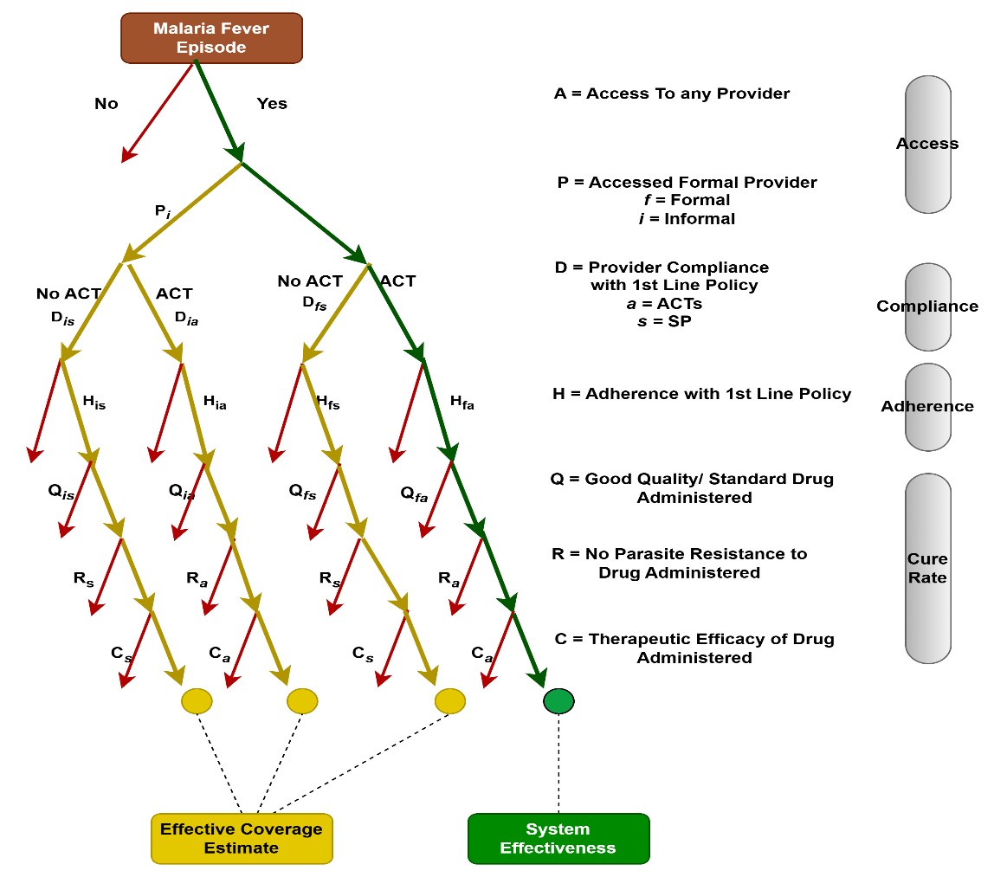

**Figure 1: Malaria Case Management Decision Tree Cascade Model Depiction. Original Design by Galactionova K, et. al. 2015**

These parameters are combined as shown in the equation (EQ. 1) denoted below to provide a measure of effective coverage (E) defined as the probability of a clinical and parasitological cure for an episode of malaria fever. See supplementary material S1 Methods for EQ. (1) and EQ. (2) details

 EQ. (1)

Cure rate indicator is modelled to account for prescribed antimalarial quality, prevalence of drug resistance to the prescribed treatment, and the clinical therapeutic efficacy of the prescribed treatment as denoted in EQ. 2 below.

 EQ. (2)

**b) Data sources and extraction**

To estimate effective coverage, we derive service performance indicators related to access to care for fever episode, type of provider sought, and compliance with malaria case management first line treatment guidelines from the demographic health surveys conducted in Kenya from 2003 to the most recent one in 2022 (10). These surveys include two types, the Demographic Health Surveys (DHS) and the malaria targeted indicator survey, the Multiple Indicator Cluster Surveys (MICS) (20). Malaria indicator questions are incorporated into the survey questionnaire with children under five born to a woman of reproductive age as the unit of analysis. Datasets provide information on diarrhoea, fever/cough, immunization coverage, and vitamin A supplementation among others. Malaria questions are based on service use during the last known episode of fever and/or cough and assessed within a 14-day recall period survey method (4)

Our analysis in concurrence with a previous similar study (4), assumed that healthcare seeking behaviours for malaria fever in the formal and informal care systems is similar across all cause febrile illness care seeking, therefore source of treatment assessed as a proportion of all cause febrile cases was deemed representative of malaria fevers. The analysis applied provider compliance to recommended first line treatment prescription as recommended by country specific guidelines. This assumed that febrile illness treated for other causes can be presumed to not be malaria. Literature provides justification of such presumption on evidence of prevalent symptomatic treatment despite improved diagnostic measures in recent years (22). Poor recall of diagnosis and testing related to malaria episodes in DHS/MICS surveys have also been cited while evaluating the survey findings for recall bias (4). Our analysis found DHS/MICS surveys prior to 2014 did not collect data on diagnosis and testing, leading to our assumption as stated.

Kenya introduced artemether lumefantrine (AL) as the first line recommended antimalarial of choice in 2004. Appropriately we analysed compliance with recommended first line treatment for the year 2003 to oral Sulfadoxine-Pyrimethamine (SP)(17). Adherence data to first line treatment guideline is limited even with improved ACTs uptake in Kenya post first line treatment policy introduction (16,17,19,23). We maintained the assumptions on adherence, cure rate and non-first line treatment as derived in Galactionova et al for the year 2003 and changed for the years thereafter to reflect the policy change scenario(4). The analysis, applied adherence rate to provider compliance with first line prescription and assumed conservatively that following ACT administration and completion of the full 3-day course cleared parasitaemia. Literature indicates strict adherence to the Kenya National Strategy for control and treatment and availability of ACTs may influence observed high adherence rates (23,24). In keeping with recent data trends, we derived our adherence estimate from Malaria Health Facility Assessment of 2023 that evaluated for adherence to malaria guidelines among other indicators (25). The report estimated 90.5% of malaria test positive patients were treated with Artemether Lumefantrine.We also assumed a treatment coverage of 80% lower in the informal care systems compared to the formal care systems. To standardize non-compliance with first line treatment guidelines, we proxy the analysis to therapy with Sulfadoxine-Pyrimethamine (SP), due to limited data on non-ACTs prescription and its associated therapeutic efficacy studies data (4)

Cure rate was modelled as a function of the quality of drugs, resistance of parasites and clinical therapeutic efficacy to the drugs prescribed. Reliable data on the extent of poor-quality antimalarial prevalence estimates is limited, and previous authors advice caution in interpretation and use of the high estimates sometimes reported due to the variability of methods used to measure the estimates and a lack of international standard definitions of the different types of poor-quality drugs (26–28). Studies analysing chemical assays and packaging analysis estimate up to one third of antimalarials in Sub Saharan Africa have failed chemical assay results. Estimates for sub-standard Artemether Lumefantrine (ALU) in Kenya vary between 5 – 8.3% (29,30), with our analysis choosing conservatively the upper limit. Overall failure rates of antimalarials tested for quality was low in Kenya compared to 13% - 35% in the East African region (29). We assumed poor quality and sub-standard drugs are dispensed in the informal sector and standard drugs are dispensed in the formal sector healthcare systems

Antimalarial resistance, another aspect of the cure rate estimate, remains low in Kenya, with ACTs effectiveness estimates remaining high in the Sub-Saharan Africa region(31). No resistance to ALUs have been reported in Kenya, despite reports of resistance related gene mutations (32). Clinical efficacy of first line antimalarial treatment in Kenya was derived from the WHO’s Report on Antimalarial Drug Efficacy, Resistance and Response report, that reviewed study reports from 2010 – 2019. Reported, efficacy studies estimated a median 2.8% failure rate for studies with a minimum follow up period of 28 with PCR testing (33). To standardise analysis of non-ACT antimalarials, we proxied parasitological failure rate to Sulfadoxine-Pyrimethamine median value failure rate of 33% as defined in previous studies (4).

**Dynamic modelling of malaria transmission**

Malaria transmission models help in understanding the dynamics of malaria transmission and the impact of various interventions. Extensive reviews of the types and complexities of such models have been described by various authors (34–36). We chose a deterministic compartmental model developed by Clara et al. 2020 (37), due to its simplicity and effectiveness in illustrating the impact of different case management scenarios and is accessible to non-modelling audience. The model framework is available as an R package on GitHub [(*swisstph.github.io/VivaxModelR/)*,](https://swisstph.github.io/VivaxModelR/index.html) complete with a detailed vignette for model calibration and simulations. The framework allows for direct integration of varying case management performance and antimalarial effective coverage, making it ideal for our analysis (21,37). The original model, approximates the transmission process with inter-human transmission similar to a classical SIS compartment model with only two populations, the susceptible and infectious groups S and I by removing vector dynamics equations. The model's R package, `*VivaxModelR`*, provides functions to simulate a compartmental model for malaria and calculate the associated reproduction number for a given epidemiological setting. In-depth details of the model’s description, parametrization, validation and sensitivity analysis have also been described, with the model authors also describing model application at country level to quantify intervention impact (21,37)

Although initially developed for *P. vivax*, parameter modifications make it suitable for *P. falciparum* transmission dynamics for a given epidemiological setting, see (S2 methods) for details. Hence, for *P. falciparum* dynamics, we consider the pertinent parameters which include: **transmission rate** **lambda (λ)** – the rate at which susceptible individuals become infected, **blood parasite clearance rate (r**)– the rate at which infected individuals clear the blood-stage parasites, and the **effective coverage rate alpha (α)** – the proportion of infections receiving timely effective treatment. By promptly and effectively treating these individuals it reduces the time an individual spends in the “infected” compartment and contributes to onwards transmission of malaria (20,36). The modified *P. falciparum* model can be represented as Figure (2) with the Vivax dynamics highlighted in red excluded. The models’ set of ordinary equations can be described as denoted in the equation denoted below EQ. (3). A description and the rationale for choosing the formulation is presented in supplementary (S2 Methods).

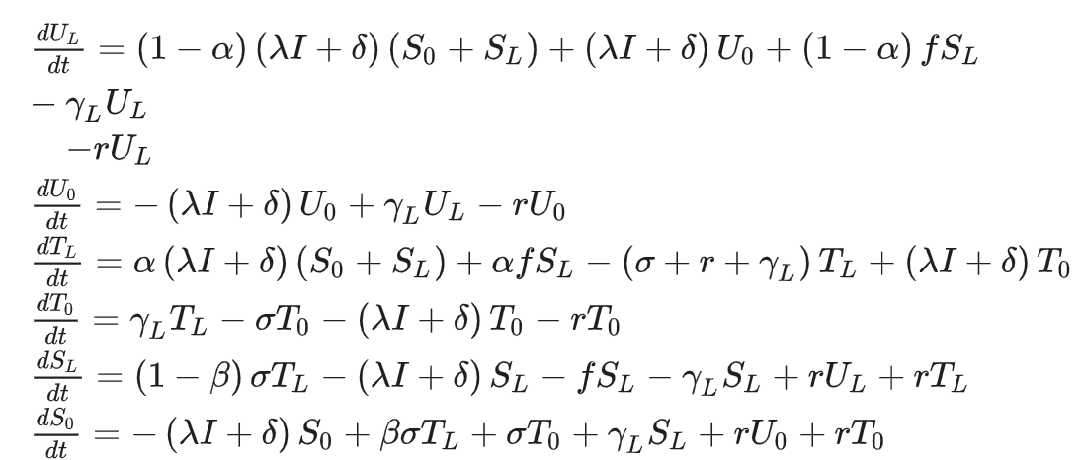

EQ. (3)

As mentioned in Champagne et al. (2022), vector control can be included in the model as a reduction in the intensity of transmission 𝜆. As our modelling focused solely on the impact of improving case management’s effective coverage, and the value of the vector control measures at baseline could not be estimated, future intervention scenarios needed to be interpreted as maintaining the same level of vector control as the baseline.

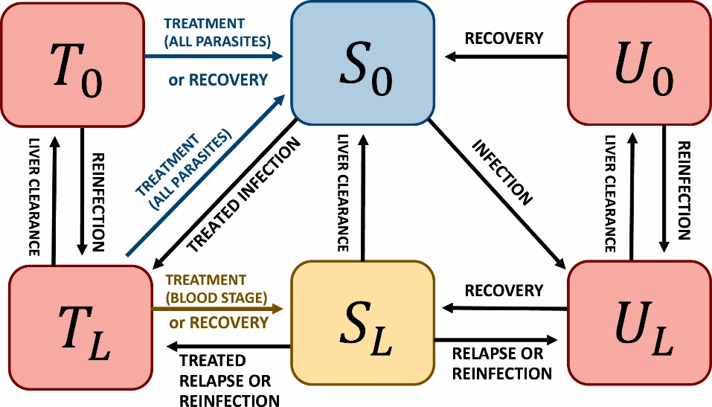

**Figure 2: Schematic modified P. falciparum model representation; Vivax dynamics highlighted in red excluded when running model simulations by modifying specific parameters**

**b) Data requirements**

To compute the transmission parameter λ from the observed incidence, the model uses the equilibrium solution of the ODE equations, accounting for ongoing control interventions. The transmission parameter λ (lambda) estimate and blood parasite clearance rate (*r*) can then be plugged into the model to calculate setting-specific reproductive numbers *RC​* and *R0.* These reproduction numbers reflect the transmission potential of a given setting in the absence of importation, with *RC​* representing the current level of interventions and *R0* representing the absence of interventions. The observed incidence *h* is defined as denoted in Eq. (4), see S2 Methods for equation description;

**[(𝜆𝐼∗+𝛿) (1−𝐼∗) +𝑓 S∗ 𝐿] ρ [(λI∗ +δ) (1−I∗) +fS∗ L​]** EQ. (4)

Baseline parameter values, including incidence and importation data, were derived from the Kenya Malaria Indicator Survey 2020 report, which provides reliable epidemiological estimates at the national, urban, rural levels, and for five malaria endemicity zones. The Kenya Malaria Strategy 2019 – 2023 recommends targeted elimination strategies for four sub national regions. WHO defines malaria elimination as the interruption of local transmission (reduction to zero incidence of indigenous cases) of a specified malaria parasite species in a defined geographic area as a result of deliberate efforts (38). The 2020 survey reported a national prevalence of 6% and 19% for the lake endemic region, the area with the highest malaria incidence in Kenya. Annual incidence rates per 1000 population were obtained from the Kenya Health Information System portal, which collects and manages formal healthcare service data. We derived an incidence of 104 cases per 1000 population for the whole country in 2023, and an average of 430 cases per 1000 population for the eight counties in the lake endemic region. These incidence estimates, combined with effective coverage estimates derived using the effective cascade model, were used to calibrate our compartmental model and analyse the impact of case management interventions on malaria epidemiological outcomes.

**Interactive visualization of model results dashboard**

Simplified data visualization allows for integration of data from different sources, its manipulation and intuitive ways of interpreting the outcomes (39,40). An interactive dynamic shiny app dashboard was developed, to allow inputs by a user to visualize the effective case management cascade estimate and the associated deterministic SIS model impact scenarios of improving the effective coverage estimate. The SIS model uses the effective coverage estimates from the cascade model to evaluate the overall effect of different case management scenarios on incidence and prevalence

The layout of the dashboard contains a side panel with 9 slider indicators estimate input rows that are attributed to effective cascade model inputs, malaria treatment drugs inputs, and the SIS model inputs. The main panel of the dashboard outputs the effective cascade model output, and the SIS impact plots on incidence and prevalence achieved by improving the effective coverage estimate

The shiny app contains two main sections components the ui.R and the sever.R section. The ui.R contains the dashboard layout and appearance code while the sever.R contains the R code script instructions for running the effective cascade and the compartmental model outputs. The complete annotated R script and the associated files are published in the online via a GitHub page ([*mghCandidate1083832 (github.com*](https://github.com/mghCandidate1083832)).

The dashboard derives input from a user. They include indicators for provider access, fever care seeking, proportion of antimalarials prescribed, proportion of treatment adherence to guidelines, ACT and non-ACT cure rates to estimate the effective coverage. Yearly reported incidence per 1000 population and proportion of cases accurately reported and captured by the system are defined for the compartmental model outputs

The complete annotated R scripts for all the methods described above and the associated files are published in the online via a GitHub page *(github.com/mghccandidate1083832/mghcandidate1083832)*, see S3: methods supplementary for reference

**Table 1: Definitions, data sources for the various parameters used in the effective cascade model and the compartmental SIS model**



**RESULTS**

The effective coverage estimates for malaria case management in Kenya varied from 39% in 2003 to 54% in 2022 (Figure 3). The estimate was lowest during the 2008 – 2009 survey at 36%, when the survey was conducted post ACT introduction in 2004The highest coverage estimate was 60%, estimated during the 2015 Malaria Indicator Survey (MIS). According to our results, effective coverage values seem to be heterogeneous throughout the country. Focusing on the five endemicity zones identified, by the National Malaria Control Program, eight counties in the western part of the country make up the lake endemic zone region, and account for about 75% of total malaria cases and the highest prevalence rate of 19% (8). During the most recent survey of 2022, in the lake endemic region on average 59.1% malaria fevers were effectively treated (Table 3).

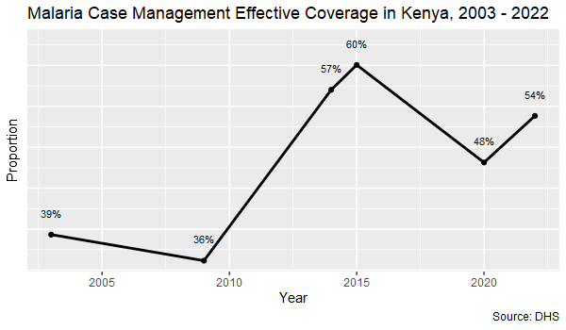

**Figure 3: Modelled effective coverage estimates for malaria case management in Kenya, 2003 - 2022**

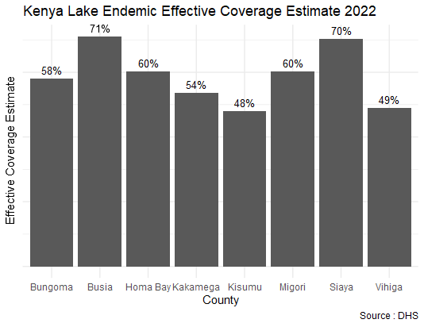

**Figure 4: Modelled effective coverage estimates for malaria case management in Lake Endemic Region, Kenya, 2022**

We estimated healthcare seeking rate nationally during analysis period was 68.5% fevers managed either in the formal or informal healthcare systems. When care was sought, formal care systems managed 82.3% of malaria fevers and 82.2% of all service providers complied with recommended first line medication for uncomplicated malaria (Table 2), Figure 5 displays the malaria cascade indicators variation for the analysis period. During the most recent survey, 2022, overall care seeking in the formal and informal care systems was 69.2%. In same period we estimate 82.1% of malaria fevers sought care in the formal care systems and 82.9% of formal and informal care providers complied with the first line policy medication. Lake endemic region 2022 survey results are shown in (Figure 4) and (Table 3). For complete country 2022 survey supplementary data S1: Results Text and S2: Results. The individual cascade plots for each year are presented as supplementary data S3: Results

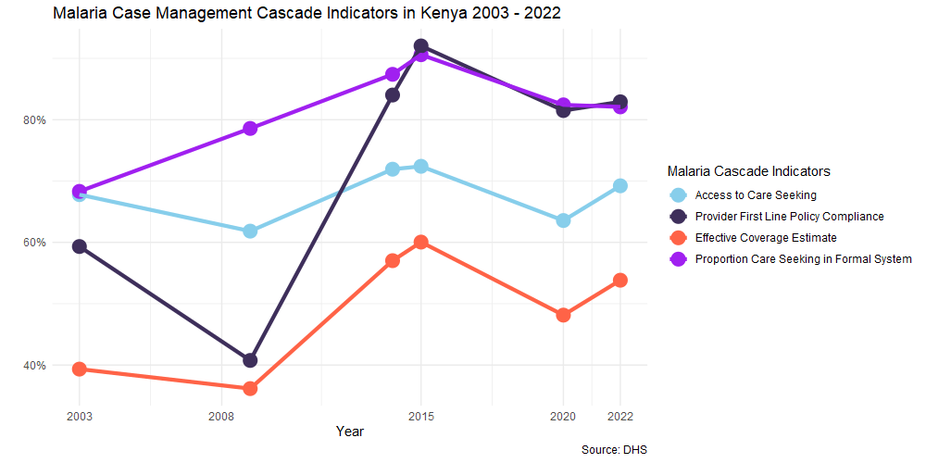

**Figure 5: Malaria Cascade indicators variation for Kenya, 2002 - 2022**

**Table 2: Table showing average malaria case indicator values for Kenya, 2003 - 2022**



**Table 3: Table showing average and individual malaria case indicator values for Lake Endemic Region, 2022**



Based on the literature review we conservatively estimated 8.3% of Artemether Lumefantrine are prescribed through the informal healthcare systems such as private pharmacies, private hospitals and clinics are of sub-standard or of poor quality. The estimate varied from 5% to 10% across the east Africa region in the various drug analysis studies. We estimated non-ACT prevalence of substandard or poor-quality drugs at 33% for Sulfadoxine-Pyrimethamine, our analysis proxy drug. The estimate was informed by similar previous study (29,30). ACTs remain highly effective in Kenya; therapeutic efficacy studies estimate them to be 97.2% efficacious (33). We maintained the therapeutic efficacy of the non-ACT antimalarial Sulfadoxine-Pyrimethamine Pyrimethamine at 53% similar to previous analysis (4). ACT resistance was not reported in Kenya up to the time of this analysis and we did not take it into account in calculation of cure rates. Cure rates for ACT’s and non-ACT drugs prescribed in the informal care systems were estimated as 88.9% and 20% respectively.

Our model supports the impact of case management strengthening – effective coverage values 80% and 95%- where malaria incidence decline is particularly highlighted, showing significant reductions in incidence over time, although not sufficient for elimination within the modelled timeline. Model output plots (Figure 6 -7) show, improvements of effective coverage above 95% seem to lead to incidence decline sufficient for elimination targets at the national level, or sub nationally in the high incidence lake endemic region within five years of implementation (3 – 5 years). These decline in incidence and prevalence (Figure 8 – 9) are modelled with the presumption of improvements on case management strategy only, while all other aspects of vector control and other strategies remain constant as at baseline.

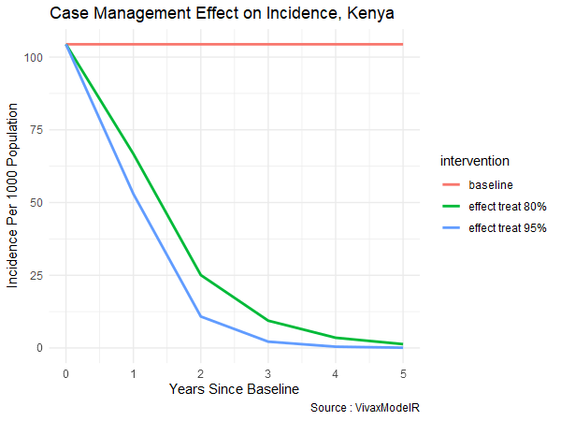

**Figure 6: Modelled effect of case management effective coverage estimate on the incidence estimates using a compartmental model, Kenya, 2024**

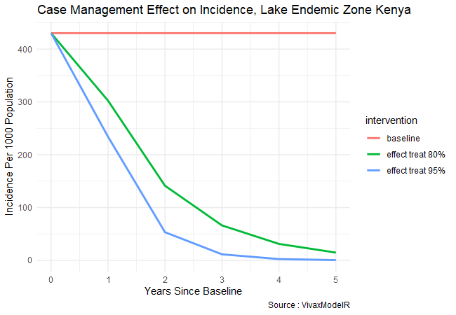

**Figure 7: Modelled effect of case management effective coverage estimate on the incidence estimates in the lake endemic region using a compartmental model, Kenya, 2024**

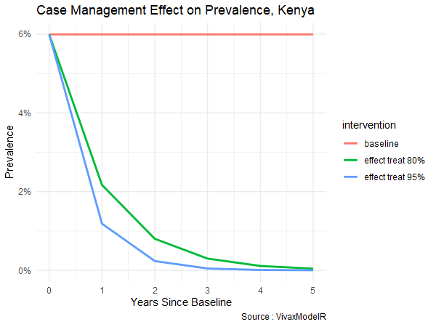

**Figure 8: Modelled effect of case management effective coverage estimate on prevalence estimates using a compartmental model, Kenya, 2024**

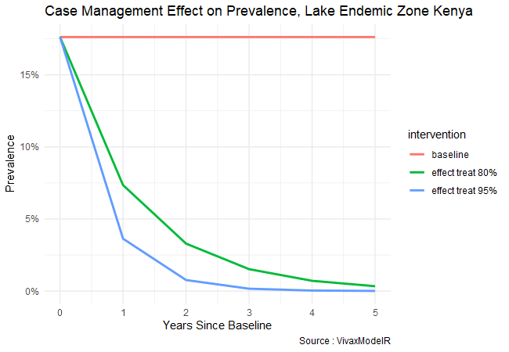

**Figure 9:Figure 9: Modelled effect of case management effective coverage estimate on the prevalence estimates in the lake endemic region using a compartmental model, Kenya, 2024**

The interactive dashboard created an interactive and intuitive Kenya Case Management Cascade dashboard that takes inputs of case management indicators and provides an estimate of the malaria cases that are effectively being treated. The dashboard also provides and output of a dynamic compartmental model on the impact of effective coverage estimate on malaria incidence estimates by the screenshot of the landing page of the dashboard in Figure 10.

**A**

**B**

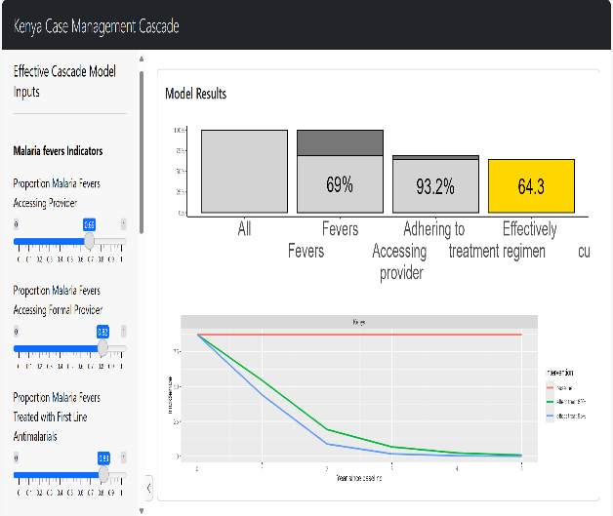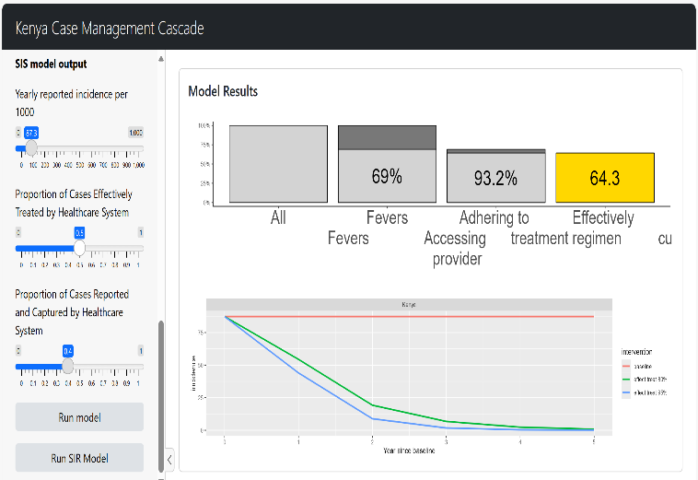

**Figure 10: A screenshot of the landing page for the effective coverage malaria dashboard showing the Cascade output bar chart and the compartmental model Incidence effect plot. Screenshot A contains sliders inputs for the effective coverage estimate inputs, while screenshot B indicates slider inputs for the compartmental SIS model**

**DISCUSSION**

While effective coverage estimate for malaria case management has improved overtime, levels still remain lower than targets of 100% coverage as envisioned by the Kenya malaria Strategy 2019 – 2023. We found the effective coverage estimate improved over the analysis period with highest levels estimated in 2015 and it has since declined in the 2022 survey. Zurovac et al (17) in their analysis of the quality of malaria case management under the test and treat policy in Kenya found similar improvements in the all-case management indicators (17). We estimated coverage to be higher in the lake endemic region compared to the non-endemic regions, although coverage estimate remained lower for the coastal endemic region in our analysis despite declining prevalence. These findings are in agreement with Amboko and other’s study findings of 2021 in Kenya who found high compliance with the test and treat policy was statistically significant around the lake endemic region while assessing improvement trends of healthcare worker compliance with said policy (41). Extensive experience of healthcare workers and regular quality improvement support supervision have been proposed as possible drivers of the improvements in high endemic settings by studies such as these studies in Kenya (41) and Nigeria (42). Further analysis is required to assess case management implementation gaps in low endemicity settings to guide tailoring of improvement activities.

On average we estimate about one third of malaria fevers don’t seek care, but when it is sought, majority in upwards of 80% seek care through the formal care systems, and compliance to first line treatment policy is also significantly higher, upwards of 80%. Further analysis to understand why people in communities are not accessing seeking care is required, as studies have shown treatment seeking behaviour for malaria differs among communities. Studies in Kenya(43,44), Nigeria (45) and Ghana (46) found out factors such availability, accessibility, affordability of malaria treatment, age and gender of persons with fever could affect care seeking.

ACT efficacy remains high in Kenya with no reported cases of ACT resistance (30,33). Data availability on poor quality and sub-standard drugs remains scarce despite informal care systems accounting for majority of this challenge as shown by Renschler et al 2015 (47). Policy institutions advocate for continuous surveillance, with recent calls to increase molecular surveillance uptake among the endemic countries (33).

Our modelling simulation supported a decline in malaria incidence and prevalence estimates, following improving of effective coverage estimates, similar findings were described by Penny et al 2015 showing an effect on reducing malaria prevalence due to high levels of treatment coverage (48). Modelling predictions can be used to compare the relative impact of implementing various control strategies to inform programmatic planning (3,21,36). Our modelling was limited to analysing the impact of case management on malaria epidemiologic estimate outcome, while not considering improvements on the other control strategies. The analysis aimed at estimating the relative impact of improving case management’s effective coverage while avoiding making future predictions as that would require simulations to include selected intervention mixes, current epidemiologic, and vector data.

Data from the effective coverage cascade, the compartmental model, coupled with visualization techniques using R shinny app allowed for datasets to be manipulated and presented visually to a user, allowing them to perceive the impact of case management on malaria incidence and prevalence estimates. The platform could provide a real-time analysis to programmatic technical staff, aiding them to identify gaps in the effective treatment of malaria cases. Such dashboards could prove pivotal in helping control programs in programmatic planning and tailoring of interventions, this is in agreement to similar studies on interactive data visualization platforms (49,50).

**Limitations**

Our analysis was limited to using DHS data, as such data on malaria testing was not available for the analysis period until after 2014 surveys and was not included in the analysis. The compartmental model only simulated for case management improvement and did not include other intervention improvements and as such could not be generalized to the country control efforts.

**Competing Interests**

The author declares that no competing interests exist

**Financial disclosure**

The author received no specific funding for this work

**Author Contributions**

Conceptualization – GG, LW, EP

Data curation – GG, MV

Formal analysis - GG, MV, AJ

Methodology - GG, MV, AJ

Resources - GG, MV, AJ, EP, CC, MG

Supervision – LW, EP, MG

Software – GG, MV, CC, MG, EP

Visualization – GG, MV

Writing – Original draft: GG

Writing – Review and Editing – GG, MV, AJ

**Data availability**

The source for the DHS data can be found, requested and downloaded from the DHS program website (www.dhsprogram.com) and the Kenyan data used for this analysis is made available with this dissertation S1: Data – Kenya Children Recode files. The other required excel files needed to run the code for recoding and running compilation codes are also included with the dissertation, S2; Data Excel Recode and output files

**Code availability**

All code can be found on GitHub at <https://github.com/mghCandidate1083832/Candidate_1083832_GitHub_Upload>. Details on the contents and structure of the code are provided in supplementary data S3: Methods R code Text

**REFERENCES**

1. WHO. World malaria report 2023

2. Bhatt S, Weiss DJ, Cameron E, Bisanzio D, Mappin B, Dalrymple U, et al. The effect of malaria control on Plasmodium falciparum in Africa between 2000 and 2015. Nature 2015 526:7572

3. Korenromp E, Mahiané G, Hamilton M, Pretorius C, Cibulskis R, Lauer J, et al. Malaria intervention scale-up in Africa: Effectiveness predictions for health programme planning tools, based on dynamic transmission modelling

4. Galactionova K, Tediosi F, De Savigny D, Smith T, Tanner M. Effective Coverage and Systems Effectiveness for Malaria Case Management in Sub-Saharan African Countries. PLoS One10(5): e0127818.

5. WHO/USAID. New Perspectives Malaria Diagnosis - Report of a Joint WHO/USAID Informal Consultation. 1999

6. WHO GMP. Scaling up diagnostic testing, treatment and surveillance for malaria. 2012. 12 p.

7. WHO. World Malaria Report: 20 years of global progress and challenges. World Health Organization. 2020.

8. DNMP Kenya, ICF. Kenya Malaria Indicator Survey 2020. 2021;158.

9. DNMP Kenya. Kenya Malaria Strategy 2019–2023. 2019.

10. KNBS. Kenya Demographic and Health Survey 2022 - Key Indicators Report.

11. Chuma J, Amin A, Nyandigisi A, Tetteh G. Access to prompt and effective malaria treatment in Kenya: A review of the literature. 2008

12. Amboko B, Stepniewska K, Macharia PM, Machini B, Bejon P, Snow RW, et al. Trends in health workers’ compliance with outpatient malaria case-management guidelines across malaria epidemiological zones in Kenya, 2010–2016.

13. Chuma J, Amin A, Nyandigisi A, Tetteh G. Access to prompt and effective malaria treatment in Kenya: A review of the literature. 2008

14. Guyatt HL, Snow RW. The management of fevers in Kenyan children and adults in an area of seasonal malaria transmission. 2004; 98(2):111–5.

15. Stanley CC, Chirombo J, Msuku H, Phiri VS, Patson N, Kazembe LN, et al. Prompt treatment-seeking behaviour varies within communities among guardians of children with malaria-related fever in Malawi. Malar J [Internet]. 2023; 22(1):1–12.

16. Odhiambo FO, O’Meara WP, Abade A, Owiny M, Odhiambo F, Oyugi EO. Adherence to national malaria treatment guidelines in private drug outlets: a cross-sectional survey in the malaria-endemic Kisumu County, Kenya. 2023; 22(1):307.

17. Zurovac D, Githinji S, Memusi D, Kigen S, Machini B, Muturi A, et al. Major Improvements in the Quality of Malaria Case-Management under the “Test and Treat” Policy in Kenya. PLoS One. 2014 Mar;9(3): e92782.

18. Hussein AK, Tarimo D, Reaves EJ, Chacky F, Abade AM, Mwalimu CD, et al. The quality of malaria case management in different transmission settings in Tanzania mainland, 2017–2018. PLOS Global Public Health. 2023;3(8): e0002318.

19. Banek K, Lalani M, Staedke SG, Chandramohan D. Adherence to artemisinin-based combination therapy for the treatment of malaria: a systematic review of the evidence. Malar J [Internet]. 2014 Jan 6;13(1):7.

20. Croft TN, Allen, Zachary CK, Blake W. Guide to DHS Statistics - DHS-8. 2023.

21. Champagne C, Gerhards M, Lana JT, Le Menach A, Pothin E. Quantifying the impact of interventions against Plasmodium vivax: A model for country-specific use. Epidemics. 2024 Mar 1;46.

22. Graz B, Willcox M, Szeless T, Rougemont A. “Test and treat” or presumptive treatment for malaria in high transmission situations? A reflection on the latest WHO guidelines; 10:136.

23. Ogolla JO, Ayaya SO, Otieno CA. Caretakers’ self-adherence to artemisinin lumefantrine in Nyando district, Kenya. 2015 Feb 23;3(1).

24. Jones C, Talisuna AO, Snow RW, Zurovac D. “We were being treated like the Queen”: Understanding trial factors influencing high paediatric malaria treatment adherence in western Kenya 2018 Jan 5;17(1):1–10.

25. Ministry of Health (2023). Malaria Health Facility Assessment, 2023. Nairobi; 2023 Jun.

26. Chaccour C, Kaur H, Del Pozo JL. Falsified antimalarials: A minireview. Expert Rev Anti Infect Ther. 2015 Apr 1;13(4):505–9.

27. Tabernero P, Fernández FM, Green M, Guerin PJ, Newton PN. Mind the gaps - The epidemiology of poor-quality anti-malarials in the malarious world - Analysis of the WorldWide Antimalarial Resistance Network database. 2014 Apr 8; 13(1):1–14.

28. Nayyar GML, Breman JG, Newton PN, Herrington J. Poor-quality antimalarial drugs in southeast Asia and sub-Saharan Africa. Lancet Infect Dis. 2012 Jun 1;12(6):488–96.

29. Organization WH. Survey of the quality of Selected antimalarial medicineS circulating in Six countrieS of Sub-Saharan africa. 2011.

30. Girma M, Umeta B, Hasen G, Suleman S. Quality of Antimalarial Drugs in East Africa: A Systematic Review. Infect Drug Resist. 2022; 15:6085.

31. Schmedes SE, Patel D, Dhal S, Kelley J, Svigel SS, Dimbu PR, et al. Plasmodium falciparum kelch 13 Mutations, 9 Countries in Africa, 2014–2018 - Emerging Infectious Diseases journal - CDC. 2021 Jul; 27(7):1902–8.

32. Owoloye A, Olufemi M, Idowu ET, Oyebola KM. Prevalence of potential mediators of artemisinin resistance in African isolates of Plasmodium falciparum. 2021 Dec 1; 20(1):1–12.

33. Organization WH. Report on antimalarial drug efficacy, resistance and response: 10 years of surveillance (2010– 2019). Geneva; 2020.

34. Mandal S, Sarkar R, Sinha S. Mathematical models of malaria - A review. 2011 Jul 21; 10(1):1–19.

35. Silal SP, Little F, Barnes KI, White LJ. Sensitivity to model structure: a comparison of compartmental models in epidemiology. 2016 Oct 1; 5(3):178–91.

36. Malaria GP to RB, Chitnis N, Schpira A, Smith D, Hay SI, Smith T, et al. Mathematical modelling to support malaria control and elimination / Nakul Chitnis … [et al]. Geneva: World Health Organization; 2010. (Progress & impact series; n. 5).

37. Champagne C, Gerhards M, Lana J, García Espinosa B, Bradley C, González O, et al. Using observed incidence to calibrate the transmission level of a mathematical model for Plasmodium vivax dynamics including case management and importation. Math Biosci. 2022 Jan 1;343.

38. Alonso P. A framework for malaria elimination.

39. Yadav CP, Sharma A. National Institute of Malaria Research-Malaria Dashboard (NIMR-MDB): A digital platform for analysis and visualization of epidemiological data. 2022 Oct 1; 5.

40. Sironi A Pietro, Bertoldo J, Sampaio V, Coimbra D, Rasella D, Barreto ME. Malaria-VisAnalytics: a tool for visual exploratory analysis of Brazilian public malaria data. 2022 Dec 1; 21(1):1–16.

41. Amboko B, Stepniewska K, Malla L, Machini B, Bejon P, Snow RW, et al. Determinants of improvement trends in health workers’ compliance with outpatient malaria case-management guidelines at health facilities with available “test and treat” commodities in Kenya. 2021 Nov 1; 16(11).

42. Bello DA, Hassan ZI, Afolaranmi TO, Tagurum YO, Chirdan OO, Zoakah AI. Supportive supervision: An effective intervention in achieving high quality malaria case management at primary health care level in Jos, Nigeria. 2013 Oct; 12(4):243–51.

43. Zhou G, Hemming-Schroeder E, Gesuge M, Afrane YA, Lee MC, Atieli HE, et al. Gaps between Knowledge and Malaria Treatment Practices after Intensive Anti-Malaria Campaigns in Western Kenya: 2004–2016. 2020 Jun 3; 102(6):1358–65.

44. Omondi CJ, Odongo D, Otambo WO, Ochwedo KO, Otieno A, Lee MC, et al. Malaria diagnosis in rural healthcare facilities and treatment-seeking behavior in malaria endemic settings in western Kenya. 2023 Jul 1; 3(7):e0001532.

45. Millar KR, McCutcheon J, Coakley EH, Brieger W, Ibrahim MA, Mohammed Z, et al. Patterns and predictors of malaria care-seeking, diagnostic testing, and artemisinin-based combination therapy for children under five with fever in Northern Nigeria: A cross-sectional study. 2014 Nov 21; 13(1):1–12.

46. Kwarteng A, Asante KP, Abokyi L, Gyaase S, Febir LG, Mahama E, et al. Provider compliance to artemisinin-based combination therapy at primary health care facilities in the middle belt of Ghana. 2015 Sep; 14(1):1–11.

47. Renschler JP, Walters KM, Newton PN, Laxminarayan R. Estimated Under-Five Deaths Associated with Poor-Quality Antimalarials in Sub-Saharan Africa. 2015 Jun 3; 92(6_Suppl):119–26.

48. Penny MA, Maire N, Bever CA, Pemberton-Ross P, Briët OJT, Smith DL, et al. Distribution of malaria exposure in endemic countries in Africa considering country levels of effective treatment. 2015 Oct; 14(1):1–16.

49. Kayaalpli S, Edwards HM, Stratil AS, Smith J, Ndiop M, Candrinho B, et al. Improving Coordination to Strengthen Operationalization of Malaria Surveillance and Routine Data Quality: Landscape Analysis of Current Surveillance-Related Initiatives. 2024 Jul 30; 1

50. Mboussou F, Ndoula ST, Nembot R, Baonga SF, Njinkeu A, Njoh AA, et al. Setting up a data system for monitoring malaria vaccine introduction readiness and uptake in 42 health districts in Cameroon. 2024 Apr 1; 9(4):e015312.

**Supplementary materials**

**S1 methods: effective cascade equation description**

This document contains effective model equation description and rationale for use

**S2 Methods - *P. falciparum* Dynamics VivaxModelR Ode Equation Description**

This document contains the modified VivaxModelR ODE description and rationale for each parameter and accompanying definitions

**S2 Methods - R Code Description**

This document contains text description of what each of the five R code script performs and the file names associated with each code

**S4 Methods - R Scripts**

Folder containing the five R scripts

**S5 Methods – data**

Folder containing the excel and DHS recoded .dta format files

**S1 Results - Table Results for Kenyan Sub National Regions Text**

This document contains the summarised 2022 sub national effective cascade outputs for Kenya. Individual sub national county effective coverage estimates and malaria cascade indicators outputs for the 2022 survey in a word table format presented as S2: Results supplementary data. Coverage was lowest in the low-risk endemic Marsabit County, where only 27% of malaria fevers were estimated to have been effectively managed. The Coastal endemic region, however, stable endemicity all year, had Mombasa County treating less than 40% of malaria fevers effectively.

**S2 Results - Table Results for Kenyan Sub National Results, 2022 Survey**

Ms Word table format results for Kenyan sub national results, 2022 Survey

**S3 Results - Effective Coverage Cascade Model Outputs for Each Year 2003 – 2022**

This document contains a word document with Effective Coverage Cascade model outputs for Each Year 2003 – 2022